Communication
Meaning:

The word communication has been derived from the Latin word 'Communis' which means 'common'. Thus, communication means sharing of ideas in common. "When we communication," says Wibur Schramn, "We are trying to establish a 'commonness' with someone. That is we are trying to share information, an idea or an attitude. The essence of communication is getting the receiver and the sender 'turned' together for a particular massage."

Definition:

Louis A, Allen defines communication as, "communication is the sum of all the things one person does when he wants to create understanding in the mind of another. It is a bridge of meaning. It involves a systematic and continuous process of telling, listening and understanding."

Koontz and O'Donnell are of the opinion "communication is a way that one organization member shares meaning and understanding with another."

Characteristics: Nature of Communication

- It involves at Least Two Persons: Communication involves at least two persons, a sender and a receiver. The sender is called communicator and the receiver of the message is known as communicatee. A person who speaks, writes or issues some instruction is the sender and the person for whom the communication is meant or who receives the message is the receiver or communicatee.
- Message is a Must: A message is the subject matter of communication. e.g., the contents of the letter or Speech, Order, Instructions or The suggestions. A communication must covey some message. If there is no message there is no communication.
- Communication May be Written Oral or Gestural: Communication is generally understood as spoken or written words. But in reality, it is more than that. It includes everything that may be used to convey meanings from one person to another, e.g., movement of lips, or the wink of an eye or the wave of hands may convey more meaning than even written or spoken word.
- Communication is Two Way Process: It involves both information and understanding. Communication is not complete unless the receiver has understood the message properly and his reaction or response is known to the sender. Understanding is the end of communication but it does not imply agreement.
- Its Primary Purpose is to Motivate a Response: The primary purpose of communication is to motivate response or influence human behaviour. There is no doubt that motivation comes from within but communicator can also motivate people by good drafting of message, proper timing of communication etc. to create understanding, communication should be relevant to the situation. It must always be remembered that communication is a means of motivating and not an end itself.
- Communication May be Formal or Informal: Formal communication follows the formal channels provided in the organization structure. For example, the managing director communicates with the departmental heads, say finance manager, finance manager communicates to deputy finance manager, the deputy finance manager with accounts officer and so on.
Informal communication flows from informal channels of communication which are not provided in the organization structure.
- It Flows Up and Down and Side to Side: Communication flows downward from a superior to subordinate and upward from subordinate to a superior. It also flows between two or more persons operating at the same level of authority.
- It is an Integral Part or the Processor Exchange: It refers to the exchange of ideas, feeling, emotions and knowledge and information between two or more persons.

Elements of Communication

The basic elements of communication are:

- Communication- The sender, speaker, issuer or writer- who intends to convey or transmit a message.
- Communicatee- The receiver for whom the communication is meant. He receives the information, order or message.
- Message- The subject matter of communication i.e., the content of the letter, speech, order, information, order or message.
- Communication Channel - The media by which the information and understanding are passing from the sender to the receiver. It serves as a link between the communicator and the communicatee, i.e., the levels of organization or relationships that exist between different individuals or departments of an organization.
- Response or Feedback - The effect, reply or reaction, of the information transmitted, on the communicatee i.e., successful no communication or miscommunication.

The Process of Communication

- The communicator first of all, formulates a clear idea about facts, opinions or information he wants to convey.
- The idea then translated by him into words (spoken or written), symbols or some other form of message which he expects the receiver to understand. This process is known as encoding of the message.
- The communicator selects a suitable media for transmission of the message e.g., telephone telegraph or television. The message is conveyed with the help of the media selected.

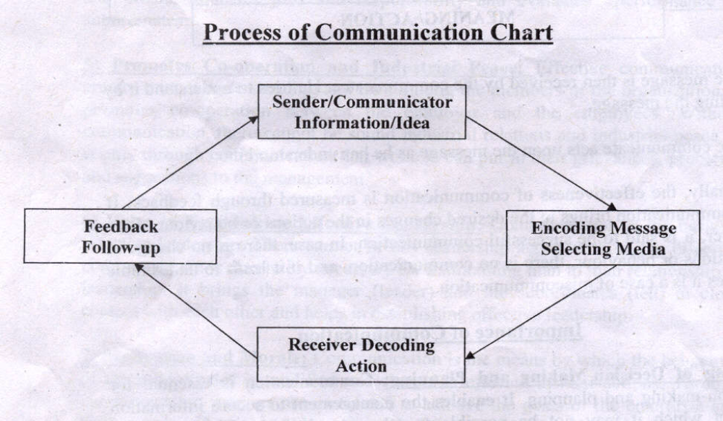
- The message is then received by the communicatee. He tries to understand it by decoding the message.
- The communicate acts upon the message as he has understood it.
- Finally, the effectiveness of communication is measured through feedback. If the communication brings ill the desired changes in the actions or behaviour of the receiver, it is said to be successful communication. In case, there is no change in the actions or behaviour, there is no communication, and if it leads to undesirable changes it is a case of miscommunication.

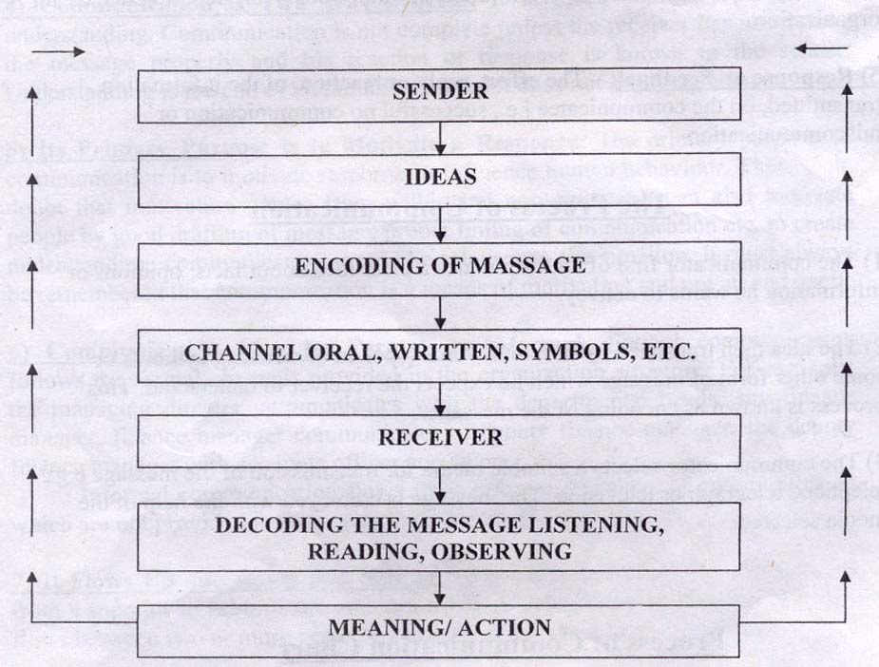

Importance of Communication

- Basis of Decision- Making and Planning: Communication is essential for decision-making and planning. It enables the management to secure information without which it may not be possible to take any decision. The quality of managerial decisions depends upon the quality of communication. Further, the decisions and plans of the management need to be communicated to the subordinates. Without effective communication, it may not be possible to issue instructions to others. Effective communication helps in proper implementation of plans and policies of the management.
- Smooth and Efficient Working of an Organization: In the words of George R. Terry, "it serves as the lubricant, fostering for the smooth operations of management process." Communication makes possible the smooth and efficient working of an enterprise. It is only through communication that the management changes and regulates the actions of the subordinates in the desired direction.
- Facilitates Co-ordination: Management is the art of getting things done through others and this objective of management cannot be achieved unless there is unity of purpose and harmony of effort. Communication through exchange of ideas and information helps to bring about unity of action in the pursuit of common purpose. It binds the people together and facilitates co-ordination.
- Increases Managerial Efficiency: Effective communication increases managerial efficiency. It is rightly said that nothing happens in management until communication takes place the efficiency of manager depends upon his ability to communicate effectively with the members of his organization. it is only through communication that management conveys its goals and desires, issues instructions and orders, allocates jobs and responsibility and evaluates performance of subordinates.
- Promotes Co-operation and Industrial Peace: Effective communication creates mutual understanding and trust among the members of the organization. It promotes co-operation between the employer and the employees. Without communication, there cannot be sound industrial relations and industrial peace. It is only through communication that workers can put in their grievances, problems and suggestions to the management.
- Helps in Establishing Effective Leadership: Communication is the basis of effective leadership. There cannot be any leadership action without the effective communication is absolutely necessary for maintaining man to man relationship in leadership. It. brings the manager (leader) and the subordinates (led) in close contact with each other and helps in establishing effective leadership.
- Motivation and Morale: Communication is the means by which the behaviour of the subordinates is modified and change is effected in their actions. Through communication workers are motivated to achieve the goals of the enterprise and their morale is boosted. Although motivation comes from within yet the manager can also motivate people by effective communication e.g., proper drafting of message, proper timing of communication and the way of communication, etc.
- Increases Managerial Capacity: Effective communication increases managerial capacity too. A manager is a human being and has limitations as to time and energy that he can devote to his activities. He has to assign duties and responsibilities to his subordinates. Through communication, a manager can effectively delegate his authority and responsibility to others and thus increases his managerial capacity.
- Effective Control: Managerial function of control implies the measurement of actual performance, comparing it with standards set by plans and taking corrective action on deviation, if any, to ensure attainment of enterprise objectives according to preconceived and planned acts communication acts as a tool of effective control. The plans have to be communicated to the subordinates, the actual performance has to be measured and communicated to the top management and a corrective action has to be taken or communicated so as to achieve the desired goals. All this may not be possible without an efficient system of communication.
- Job Satisfaction: Effective communication creates job satisfaction among employees as it increases mutual trust and confidence between management and the employees. The gap between management and the employees is reduced through the efficient means of communication and a sense of belongingness is created among employees. They work with zeal and enthusiasm.
- Democratic Management: Communication is also essential for democratic management. It helps to achieve worker's participation in management by involving workers in the process of decision-making is the absence of an efficient system of communication, there cannot be any delegation and decentralization of authority.
- Increases Productivity and Reduces Cost: Effective communication save time and effort. It increases productivity and reduces cost. Large-scale production involves a large number of people in the organization. Without communication, it may not be possible to work together in a group and achieve the benefits of large- scale production.
- Public Relations: In the present business world, every business enterprise has to create and maintain a good corporate image in the society .It is only through communication that management can present a good corporate image to the outside world. Effective communication helps management in maintaining good relations with workers, customers, suppliers, shareholders, government and community at large.

Methods (Channels) or Types of Communication:

Communication may be classified into several categories on the following basis:

- On the Basis of Organizational Structure or Relationship:
  - Formal Communication
  - Informal Communication or Grapevine.
- On the Basis of Flow or Direction:
  - Downward Communication
  - Upward Communication
  - Horizontal or Lateral or Sideward Communication
  - Diagonal Communication.
- On the Basis of Methods or Media used or Expression:
  - Written Communication
  - Oral Communication
  - Gestural or Non-Verbal Communication.

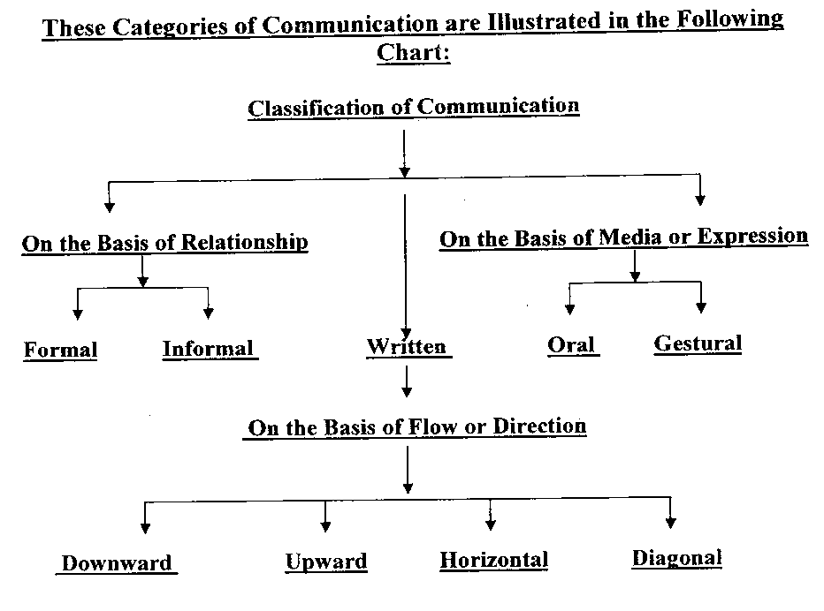

    - On the Basis of Relationship or Organization Structure:

  - Formal Communication: Formal communication is that which takes place through the formal channel of the organization structure deliberately and consciously established by the management. It implies the flow of the information along the lines of authority formally established in the enterprise. Members of the enterprise are expected to communicate with one another strictly as per channels laid down in the structure. Such communications are generally in writing and may take any of the following forms:
      - Policy Manuals;
      - Procedural and Rule Books;
      - Memoranda Papers and Orders;
      - Official Meeting;
      - Interviews, etc.
  - Informal Communication or Grapevine: Communication arising out of all those channels of communication that fall outside the formal channel is known as informal communication or the grapevine. It is built around the social relationship of members of the organization. Informal communication does not follow lines of authority as is the case of formal communication. It arises due to the personal needs of the members of an organization and exists in every organization. Such communication is usually oral and exists in even by simple glance ,gesture, smile or silence.

    - On the Basis of Flow or Direction:

- Downward Communication: Communication between a superior and subordinate is known as vertical communication. Vertical communication may be downward vertical communication or upward vertical communication. Downward communication means communication which flows from a superior to a subordinate.
The important examples of downward communication are:
- Notices
- Circulars
- Instructions
- Orders
- Letters
- Memos
- Upward Communication: Upward communication means the flow of information from the lower levels of the organization to the higher levels of authority .It passes from subordinate to superior as that from worker to foreman, from foreman to manager, from manager to general manager and form general manager to the chief executive or the board of directors. It includes opinions, ideas, suggestions, complaints, grievances, appeals, reports, etc.

Upward Communication is Needed:
  - To create receptiveness of communication
  - To create a sense of belongingness through active participation
  - To evaluate the effectiveness of communication
  - To increase morale of employees
  - To make improvements in managerial decisions
  - To co-ordinate efforts; and
  - To know ideas of each individual in the organization.

The important examples of upward communication are:
- Reports
- Meeting
- Interview
- Conferences
- Letters
- Complaints.
- Horizontal, Lateral or Sideward Communication: The transmission of information and understanding between people on the same level of organization hierarchy is called the horizontal communication. This type of communication is also known as lateral or sideward or crosswise communication. Usually, it pertains to inter-departmental communication, i.e., the communication between two departmental managers working at the same level of organization or among subordinates working under one boss.
- Diagonal Communication: The transfer of information between people who are neither in the same department nor on the same level of organization hierarchy is called diagonal communication. For example, when the assistant marketing manager communicates with the accounts clerk directly, it is the case of diagonal communication. This type of communication increases the organizational efficiency by speeding up information and cutting across departmental barriers.

    - On the basis of media or expression:

The various media of communication have been studied as under:
        - Written Communication;
        - Oral Communication;
        - Gestural or Non-verbal Communication.

- Written Communication: communication through words, may be in writing or oral. Written communication implies transmission of message in back and white it includes diagrams, pictures, graphs, etc. have to be transmitted in writing for efficient running of the organization. written communication ensures that everyone concerned has the same information. It may take the following forms:
- Reports
- Circulars
- Magazines
- Manuals
- Memoranda
- Newspapers
- Pictures, diagrams, graphs, etc.

Merits or Advantages of Written Communication:

- It ensures transmission of information in uniform manner, i.e. every one concerned has the same information.
- It provides a permanent record of communication for future reference.
- It is an ideal way of transmitting length messages.
- It ensures little risk of unauthorized alteration in the messages.
- It is the only means of exchanging information at distant places even beyond telephonic range.
- It tends to be complete, clear precise and correct.
- It can be quoted as a legal evidence in case of any disputes.
- It is suited to convey message to a large number of persons at one and the same time.

Demerits or Disadvantages of Written Communication:

- It is expensive
- It is time consumption
- It becomes difficult to maintain secrecy about a written communication.
- It is rigid and does not provide any scope for making alteration for inaccuracies that might have crept in.
- It is very formal and lacks personal touch.
- It is encourages red-tapism and involves so many formalities.
- It may be interpreted in different manner by different people.
- It oftenly becomes lengthy, when messages are conveyed in writing.

- Oral Communication: Oral or verbal communication implies the conveying of message through spoken words. It is face to face communication between individuals and includes communication through telephone, intercom and public speech, etc. in every organization, a great deal of information is exchanges orally and it is generally preferred to written communication.

Theo Haimann pointed out, "the human voice can impart the message with 'meaning and shading which even long pages of written words simply cannot convey."

It may take the following forms depending upon the need and situation,
- Face to face talks
- Telephonic conversation
- Interviews
- Meetings
- Lectures
- Conferences.

Merits or Advantages of Oral Communication:

- It is less expensive or economical as compared to written communication.
- It is quicker and saves in time.
- It is more effective than written communication.
- It establishes a personal touch and leads to greater understanding.
- Misunderstanding or doubts can be removed than and there.
- Immediate reaction, motivation or response of the receiver can be taken.
- It is more flexible and the messages can be changed to suit the needs and response of the receiver.
- It provides as the only means of conveying messages in times of emergencies.

Demerits and Disadvantages of Oral Communication:

Oral communication has the following limitations or drawbacks:
- It is less reliable.
- It is influenced by self-interest and attitude of the people.
- Oral communication has the tendency of being distorted.
- It provides no record for future reference.
- It is not suitable for lengthy message.
- It does not provide sufficient time for thinking before conveying the message.
- It has language problems, one may mean to convey something, but due to his way of speaking, it may convey something else.
- It cannot be used to communicate with people scattered over distant places.

- Gestural or Non verbal Communication: Communication does not mean merely written .or oral messages. It includes everything that may be used to convey meaning from one person to another, e.g., movement of lips or the wink of an eye or the wave of hands may convey more meaning than written or oral words. Expression through body parts is known as gestural or non-verbal communication. It includes facial expression, movement of lips, wink of an eye, nodding of heads, movement of hands, a sense of humour or a mere silence, etc.

Barriers to communication and making communication effective:
Barriers to communication:

Communication is the nerve system of an enterprise. It is said to be no. 1 management problem today. "It serves as the lubricant, fostering for the smooth operations of management process.

Barriers to communication:

- Physical Barriers: A communication is two-way process, distance between the sender and the receiver of the message is an important barrier to communication. Noise and environmental factors also block communication.
- Personal Barriers: Personal factors like difference in judgement, social values, inferiority complex, bias, attitude, pressure of time, inability to communicate, etc. widen the psychological distance between the communicator and the communicate. Credibility gap, i.e., inconsistency between what one says and what one does, also, acts as a barrier to communication.
- Semantic or Language Barriers: Semantic is the science of meaning. The same work and symbols carry different meanings to different people. Difficulties in communication arise when the sender and the receiver of the message use words or symbols in different senses. The meaning intended by the sender may be quite different from the meaning followed by the receiver. People interpret the message in terms of their own behaviour and experience. Sometimes, the language used by the sender may not at all be followed by the receiver.
- Status Barriers Superior-Subordinate Relationship: status or position in the hierarchy of an organization is one of the fundamental barriers that obstructs free flow of information. A superior may give only selected information to his subordinates so as to maintain status differences. Subordinates, usually, tend to convey only those things which the superiors would appreciate. This creates distortion in upwards communication. Such selective communication is also known as filtering sometimes, "the superior feels that he cannot fully admit to his subordinates those problems, conditions or results which may affect adversely on his ability judgement.
- Organizational Structure Barriers: Effective communication largely depends upon sound organizational structure. If the structure is complex involving several layers of management, the breakdown or distortion in communication will arise it is an established fact that every layer cuts off a bit of information.
- Barriers due to Inadequate Attention: Inadequate attention to the message makes communication less effective and the message is likely to be misunderstood. Inattention may arise because of over business of the communicatee or because of the message being contrary to his expectations and beliefs. The simple failure to read notices, minutes and reports also a con1ffion feature.
- Premature Evaluation: Some people have the tendency to form a judgement before listening to the entire message. This is known as premature evaluation. As discussed in the previous point, "half-listening is like racing your engine with the gears in neutral. You use gasoline but you get nowhere." Premature evaluation distorts understanding and acts as a barrier to effective communication.
- Emotional Attitude: Barriers may also arise due to emotional attitude because when emotions are strong, it is difficult to know, the frame of mind "of other person or group. Emotional attitudes of both, the" communicator as well as the communicatee, obstruct free flow of transmission and understanding of messages.
- Resistance to Change: It is general tendency of human beings to stick to old and customary patterns of life. 1bey may resist change to maintain status quo. Thus, when new ideas are being communicated to introduce a change, it is likely to be overlooked or even opposed. This resistance to change creates an important obstacle to effective communication.
- Barriers Due to Lack of Mutual Trust: Communication means sharing of ideas in common. "When we communicate, we are trying to establish a commonness." Thus, one will freely transfer information and understanding with another only when there is .mutual trust between the two. When there is a lack of mutual trust between the communicator and the communicatee, the message is not followed.
- Other Barriers: There may be many other barriers, such as unclarified assumptions, lack of ability to communicate, mirage of too much knowledge of closed minds, communication overload, shortage of time, etc., which cause distortion or obstruction in the free flow of communication and thus make it ineffective. Failure to retain or store information for future use becomes a barrier to communication when the information is needed in future.

Making: communication effective or overcoming / gate ways to communication

- Clarity and Completeness: In communication effectively, it is very essential to know the 'audience' for whom the message is meant. The message to be conveyed must be absolutely clear in the mind of the communicator because if you do not understand an idea, you can never express it to someone. The message should be adequate and appropriate to the purpose of communication. The purpose of communication, itself, should be clearly defined.
- Proper Language: To avoid semantic barriers, the message should be express in simple, brief and clear language. The words or symbols selected for conveying the message must be appropriate to the reference and understanding of the receiver.
- Sound Organization Structure: To make communication effective, the organization structure must be appropriate to the needs of the organization. Attempt must be made to shorten the distances to be travelled for conveying information.
- Orientation of Employees: The employees should be oriented to understand the objectives, rules, authority relationships and operations of enterprise. It will help to understand each other, minimize conflicts and distortion of messages.
- Emphatic Listening and Avoid Premature Evaluation: To communicate effectively, one should be a good listener. Superior should develop the habit of patient listening and avoid premature evaluation of communication from their subordinates. This will encourage free flow of upward communication.
- Motivation and Mutual Confidence: The message to be communication should be so designed as to motivate the receiver to influence his behaviour to take the desired action. A sense of mutual trust and confidence must be .generated to promote free flow of information.
- Consistent Behaviour: To avoid credibility gap, management must ensure that their actions and deeds are in accordance with their communication.
- Use of Grapevine: Grapevine or the informal channels of communication help to improve managerial decisions and make communication more effective. Thus formal channels of communication must be supplemented with the use of grapevine.
- Feedback: Communication is not completes unless the response or reaction of the receiver of the message is obtained by the communicator the effectiveness of communication can be judged from the feedback. Therefore, feedback must be encouraged and analysed.
- Gestures and Tone: The way you say something is also very important along with the message for gestures such as a twinkle of an eye, a smile or a handshake, etc., Convey sometimes tone meaning then ever words spoken or written. Thus, one should have appropriate facial expressions, tone, gestures and mood etc., to make communication effective.

