TYPES OF MOTHERBOARD
“The Motherboard“
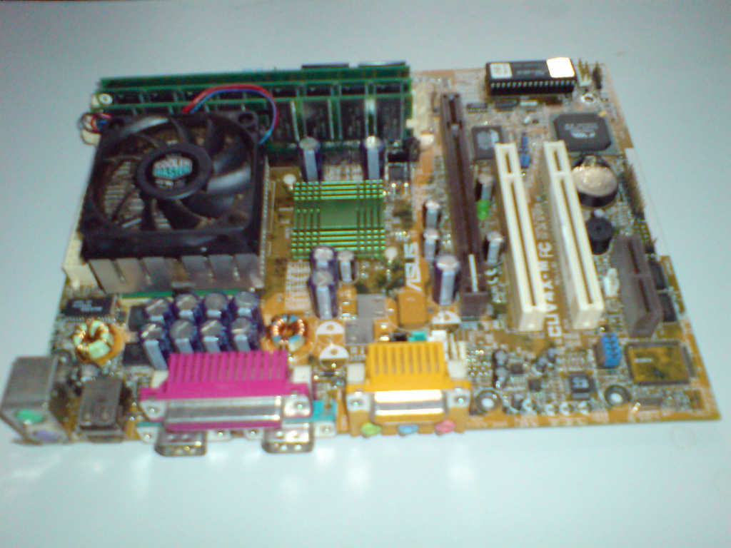
Caused by the fact that motherboards developed very fast I can only show several stages of the development of motherboards:
Let’s start in the year 1981:
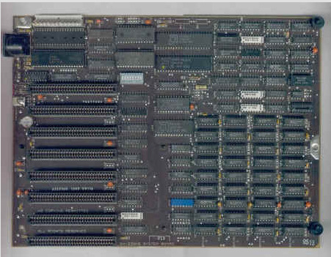
- 8-Bit technology
- provided 8-Bit slots for ISA-extension cards (Industry standard architecture)
- on the right side you can see memory (cache and RAM)

Standard mainboard for CPU 80286 (1982)
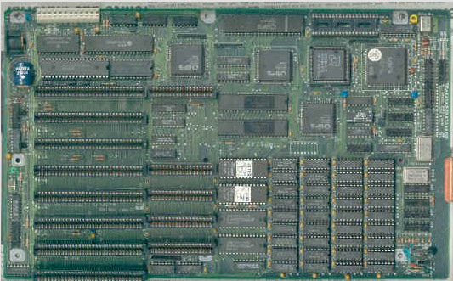
- supports also 16-Bit technology
- CPU and RAM are socketed and it was possible to remove / exchange them
- 16-Bit ISA-Slots were available for the first time

Standard PC for CPU 80386 with CO-Processor 80387
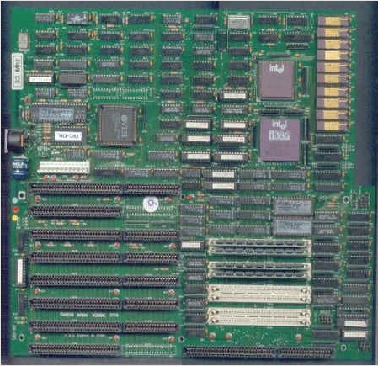
- mainboard of a 386'er Pentium
- removable RAM-benches became normal
- it was possible to use extension-memory which was an important step in the development
- a Co-Processor was used to support the CPU
- it’s easy to see that the number of used assemblies has been reduced (caused by new technologies)
- first PCI slots are visible
- CPU-sockets are familiar to modern ones
- used for Pentium II and Pentium III
- visible are the known IDE-Connectors and the power-supply-connectors
- number of PCI-slots increased (caused by the demand for more functionality)
- memory-benches support SD-RAM
- PS/2 connectors for keyboard and mouse
- dual-channel RAM-technology
- integrated sound system
- integrated graphics system (performance of 2-3 NVIDIA GeForce 3 Ti Series)
- S-ATA Connectors
- extended power supply-connector (2x2 Pin)/ 12x2 Pin
- integrated high-speed network adapter

Mainboard for CPU 80586 -Pentium I
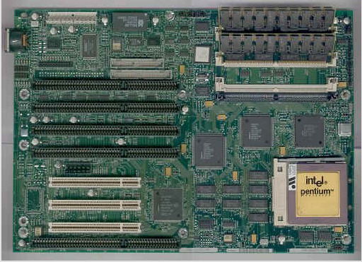
CPU 805/686 -Pentium II – III
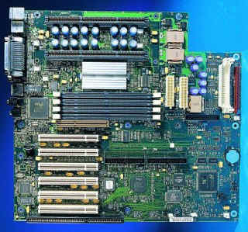
mainboard for Pentium 4 / Pentium D Series / Core 2 Duo support
Kinds of motherboards exist
Motherboards are produced in a variety of sizes and shapes (called form factors). Most common form factor today is the ATX-form (Advanced Technology Extended) which was created by Intel in 1995.
• even this ATX form is divided into different specifications: •
a short overview:
- ATX: 305 × 244 mm (12" × 9, 6").
- Mini-ATX: 284 × 208mm (11,2" × 8,2")
- Mikro ATX: 244 × 244 mm (9,6" × 9,6")
- Flex ATX: 229 × 191 mm (9" × 7,5"),
- Mini ITX: 170 × 170 mm (6,7" × 6,7") (Integrated Technology Extended)
- Nano ITX: 120 × 120 mm (4,7" × 4,7")
- Pico ITX: 100 × 72mm (4" × 2,8")
- E-ATX-form : 305 × 330 mm (12" × 13") (used for servers)

Micro-ATX mainboard CUV4X-M from ASUS
=> consequence of that form: fewer extension-ports available (for ex. Only 2x PCI)
Today’s technology is developed far enough to reduce the required space for the certain units in such an amount, that it is possible to put everything on a PCI-Card
supports Intel Pentium III
max. 256MB SD-RAM
network
integrated GPU (VGA-Port available)

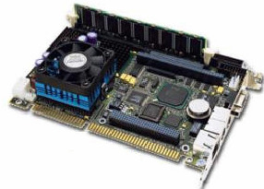

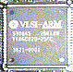 | Processor Types
ARM 1 (v1)
This was the very first ARM processor. Actually, when it was first manufactured in April 1985, it was the very first commercial RISC processor. Ever.
As a testament to the design team, it was "working silicon" in it's first incarnation, it exceeded it's design goals, and it used less than 25,000 transistors.
The ARM 1 was used in a few evaluation systems on the BBC micro (Brazil - BBC interfaced ARM), and a PC machine (Springboard - PC interfaced ARM).
It is believed a large proportion of Arthur was developed on the Brazil hardware.
In essence, it is very similar to an ARM 2 - the differences being that R8 and R9 are not banked in IRQ mode, there's no multiply instruction, no LDR/STR with register-specified shifts, and no co-processor gubbins.
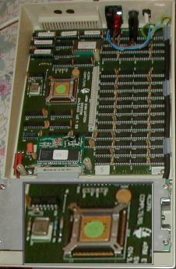
ARM evaluation system for BBC Master
(original picture source not known - downloaded from a website full of BBC-related images
this version created by Rick Murray to include zoomed-up ARM down the bottom...)
ARM 2 (v2)
Experience with the ARM 1 suggested improvements that could be made. Such additions as the MUL and MLA instructions allowed for real-time digital signal processing. Back then, it was to aid in generating sounds. Who could have predicted exactly how suitable to DSP the ARM would be, some fifteen years later?
In 1985, Acorn hit hard times which led to it being taken over by Olivetti. It took two years from the arrival of the ARM to the launch of a computer based upon it...
...those were the days my friend, we thought they'd never end.
When the first ARM-based machines rolled out, Acorn could gladly announce to the world that they offered the fastest RISC processor around. Indeed, the ARM processor kicked ass across the computing league tables, and for a long time was right up there in the 'fastest processors' listings. But Acorn faced numerous challenges. The computer market was in disarray, with some people backing IBM's PC, some the Amiga, and all sorts of little itty-bitty things. Then Acorn go and launch a machine offering Arthur (which was about as nice as the first release of Windows) which had no user base, precious little software, and not much third party support. But they succeeded.
The ARM 2 processor was the first to be used within the RISC OS platform, in the A305, A310, and A4x0 range. It is an 8MHz processor that was used on all of the early machines, including the A3000. The ARM 2 is clocked at 8MHz, which translates to approximately four and a half million instructions per second (0.56 MIPS/MHz).
ARM 3 (v2as)
Launched in 1989, this processor built on the ARM 2 by offering 4K of cache memory and the SWP instruction. The desktop computers based upon it were launched in 1990.
Internally, via the dedicated co-processor interface, CP15 was 'created' to provide processor control and identification.
Several speeds of ARM 3 were produced. The A540 runs a 26MHz version, and the A4 laptop runs a 24MHz version. By far the most common is the 25MHz version used in the A5000, though those with the 'alpha variant' have a 33MHz version.
At 25MHz, with 12MHz memory (a la A5000), you can expect around 14 MIPS (0.56 MIPS/MHz).
It is interesting to notice that the ARM3 doesn't 'perform' faster - both the ARM2 and the ARM3 average 0.56 MIPS/MHz. The speed boost comes from the higher clock speed, and the cache.
Oh, and just to correct a common misunderstanding, the A4 is not a squashed down version of the A5000. The A4 actually came first, and some of the design choices were reflected in the later A5000 design.
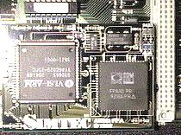
ARM3 with FPU
(original picture downloaded from Arcade BBS, archive had no attribution)
ARM 250 (v2as)
The 'Electron' of ARM processors, this is basically a second level revision of the ARM 3 design which removes the cache, and combines the primary chipset (VIDC, IOC, and MEMC) into the one piece of silicon, making the creation of a cheap'n'cheerful RISC OS computer a simple thing indeed. This was clocked at 12MHz (the same as the main memory), and offers approximately 7 MIPS (0.58 MIPS/MHz).
This processor isn't as terrible as it might seem. That the A30x0 range was built with the ARM250 was probably more a cost-cutting exercise than intention. The ARM250 was designed for low power consumption and low cost, both important factors in devices such as portables, PDAs, and organisers - several of which were developed and, sadly, none of which actually made it to a release.
ARM 250 mezzanine
This is not actually a processor. It is included here for historical interest. It seems the machines that would use the ARM250 were ready before the processor, so early releases of the machine contained a 'mezzanine' board which held the ARM 2, IOC, MEMC, and VIDC.

ARM 4 and ARM 5
These processors do not exist.
More and more people began to be interested in the RISC concept, as at the same sort of time common Intel (and clone) processors showed a definite trend towards higher power consumption and greater need for heat dissipation, neither of which are friendly to devices that are supposed to be running off batteries.
The ARM design was seen by several important players as being the epitome of sleek, powerful RISC design.
It was at this time a deal was struck between Acorn, VLSI (long-time manufacturers of the ARM chipset), and Apple. This lead to the death of the Acorn RISC Microprocessor, as Advanced RISC Machines Ltd was born. This new company was committed to design and support specifically for the processor, without the hassle and baggage of RISC OS (the main operating system for the processor and the desktop machines). Both of those would be left to Acorn.
In the change from being a part of Acorn to being ARM Ltd in it's own right, the whole numbering scheme for the processors was altered.

ARM 610 (v3)
This processor brought with it two important 'firsts'. The first 'first' was full 32 bit addressing, and the second 'first' was the opening for a new generation of ARM based hardware.
Acorn responded by making the RiscPC. In the past, critics were none-too-keen on the idea of slot-in cards for things like processors and memory (as used in the A540), and by this time many people were getting extremely annoyed with the inherent memory limitations in the older hardware, the MEMC can only address 4Mb of memory, and you can add more by daisy-chaining MEMCs - an idea that not only sounds hairy, it is hairy!
The RiscPC brought back the slot-in processor with a vengeance. Future 'better' processors were promised, and a second slot was provided for alien processors such as the 80486 to be plugged in. As for memory, two SIMM slots were provided, and the memory was expandable to 256Mb. This does not sound much as modern PCs come with half that as standard. However you can get a lot of milage from a RiscPC fitted with a puny 16Mb of RAM.
But, always, we come back to the 32 bit. Because it has been with us and known about ever since the first RiscPC rolled out, but few people noticed, or cared. Now as the new generation of ARM processors drop the 26 bit 'emulation' modes, we RISC OS users are faced with the option of getting ourselves sorted, or dying.
Ironically, the other mainstream operating systems for the RiscPC hardware - namely ARMLinux and netbsd/arm32 are already fully 32 bit.
Several speeds were produced; 20MHz, 30Mhz, and the 33MHz part used in the RiscPC.
The ARM610 processor features an on-board MMU to handle memory, a 4K cache, and it can even switch itseld from little-endian operation to big-endian operation. The 33MHz version offers around 28MIPS (0.84 MIPS/MHz).
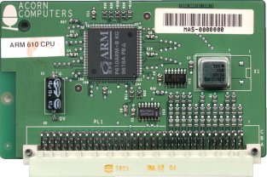
The RiscPC ARM610 processor card
(original picture by Rick Murray, © 2002)

ARM 710 (v3)
As an enhancement of the ARM610, the ARM 710 offers an increased cache size (8K rather than 4K), clock frequency increased to 40MHz, improved write buffer and larger TLB in the MMU.
Additionally, it supports CMOS/TTL inputs, Fastbus, and 3.3V power but these features are not used in the RiscPC.
Clocked at 40MHz, it offers about 36MIPS (0.9 MIPS/MHz); which when combined with the additional clock speed, it runs an appreciable amount faster than the ARM 610.
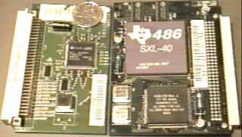
ARM710 side by side with an 80486, the coin is a British 10 pence coin.
(original picture by Rick Murray, © 2001)
ARM 7500
The ARM7500 is a RISC based single-chip computer with memory and I/O control on-chip to minimise external components. The ARM7500 can drive LCD panels/VDUs if required, and it features power management. The video controller can output up to a 120MHz pixel rate, 32bit sound, and there are four A/D convertors on-chip for connection of joysticks etc.
The processor core is basically an ARM710 with a smaller (4K) cache.
The video core is a VIDC2.
The IO core is based upon the IOMD.
The memory/clock system is very flexible, designed for maximum uses with minimum fuss. Setting up a system based upon the ARM7500 should be fairly simple.
ARM 7500FE
A version of the ARM 7500 with hardware floating point support.
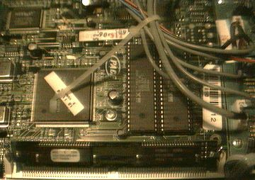
ARM7500FE, as used in the Bush Internet box.
(original picture by Rick Murray, © 2002)

StrongARM / SA110 (v4)
The StrongARM took the RiscPC from around 40MHz to 200-300MHz and showed a speed boost that was more than the hardware should have been able to support. Still severely bottlednecked by the memory and I/O, the StrongARM made the RiscPC fly. The processor was the first to feature different instruction and data caches, and this caused quite a lot of self-modifying code to fail including, amusingly, Acorn's own runtime compression system. But on the whole, the incompatibilities were not more painful than an OS upgrade (anybody remember the RISC OS 2 to RISC OS 3 upgrade, and all the programs that used SYS OS_UpdateMEMC, 64, 64 for a speed boost froze the machine solid!).
In instruction terms, the StrongARM can offer half-word loads and stores, and signed half-word and byte loads and stores. Also provided are instructions for multiplying two 32 bit values (signed or unsigned) and replying with a 64 bit result. This is documented in the ARM assembler user guide as only working in 32-bit mode, however experimentation will show you that they work in 26-bit mode as well. Later documentation confirms this.
The cache has been split into separate instruction and data cache (Harvard architecture), with both of these caches being 16K, and the pipeline is now five stages instead of three.
In terms of performance... at 100MHz, it offers 114MIPS which doubles to 228MIPS at 200MHz (1.14 MIPS/MHz).
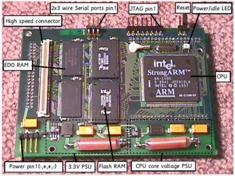
A StrongARM mounted on a LART board.
In order to squeeze the maximum from a RiscPC, the Kinetic includes fast RAM on the processor card itself, as well as a version of RISC OS that installs itself on the card. Apparently it flies due to removing the memory bottleneck, though this does cause 'issues' with DMA expansion cards.
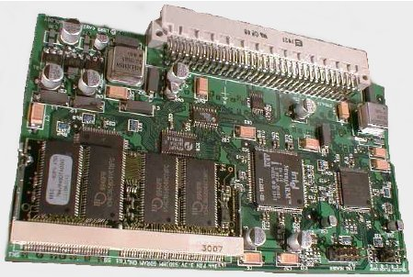
A Kinetic processor card.

SA1100 variant
This is a version of the SA110 designed primarily for portable applications. I mention it here as I am reliably informed that the SA1100 is the processor inside the 'faster' Panasonic satellite digibox. It contains the StrongARM core, MMU, cache, PCMCIA, general I/O controller (including two serial ports), and a colour/greyscale LCD controller. It runs at 133MHz or 200MHz and it consumes less than half a watt of power.

Different RAM Types and its uses
Introduction:
The type of RAM doesn't matter nearly as much as how much of it you've got, but using plain old SDRAM memory today will slow you down. There are three main types of RAM: SDRAM, DDR and Rambus DRAM.
SDRAM (Synchronous DRAM)
Almost all systems used to ship with 3.3 volt, 168-pin SDRAM DIMMs. SDRAM is not an extension of older EDO DRAM but a new type of DRAM altogether. SDRAM started out running at 66 MHz, while older fast page mode DRAM and EDO max out at 50 MHz. SDRAM is able to scale to 133 MHz (PC133) officially, and unofficially up to 180MHz or higher. As processors get faster, new generations of memory such as DDR and RDRAM are required to get proper performance.
DDR (Double Data Rate SDRAM)
DDR basically doubles the rate of data transfer of standard SDRAM by transferring data on the up and down tick of a clock cycle. DDR memory operating at 333MHz actually operates at 166MHz * 2 (aka PC333 / PC2700) or 133MHz*2 (PC266 / PC2100). DDR is a 2.5 volt technology that uses 184 pins in its DIMMs. It is incompatible with SDRAM physically, but uses a similar parallel bus, making it easier to implement than RDRAM, which is a different technology.
Rambus DRAM (RDRAM)
Despite it's higher price, Intel has given RDRAM it's blessing for the consumer market, and it will be the sole choice of memory for Intel's Pentium 4. RDRAM is a serial memory technology that arrived in three flavors, PC600, PC700, and PC800. PC800 RDRAM has double the maximum throughput of old PC100 SDRAM, but a higher latency. RDRAM designs with multiple channels, such as those in Pentium 4 motherboards, are currently at the top of the heap in memory throughput, especially when paired with PC1066 RDRAM memory.
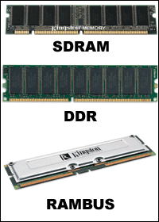
DIMMs vs. RIMMs
DRAM comes in two major form factors: DIMMs and RIMMS.
DIMMs are 64-bit components, but if used in a motherboard with a dual-channel configuration (like with an Nvidia nForce chipset) you must pair them to get maximum performance. So far there aren't many DDR chipset that use dual-channels. Typically, if you want to add 512 MB of DIMM memory to your machine, you just pop in a 512 MB DIMM if you've got an available slot. DIMMs for SDRAM and DDR are different, and not physically compatible. SDRAM DIMMs have 168-pins and run at 3.3 volts, while DDR DIMMs have 184-pins and run at 2.5 volts.
RIMMs use only a 16-bit interface but run at higher speeds than DDR. To get maximum performance, Intel RDRAM chipsets require the use of RIMMs in pairs over a dual-channel 32-bit interface. You have to plan more when upgrading and purchasing RDRAM.
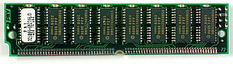
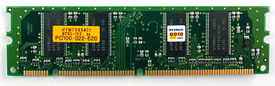
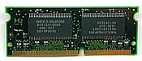
From the top: SIMM, DIMM and SODIMM memory modules
Older memory types
Fast Page Mode DRAM
Fast Page Mode DRAM is plain old DRAM as we once knew it. The problem with standard DRAM was that it maxes out at about 50 MHz.
EDO DRAM
EDO DRAM gave people up to 5% system performance increase over DRAM. EDO DRAM is like FPM DRAM with some cache built into the chip. Like FPM DRAM, EDO DRAM maxes out at about 50 MHz. Early on, some system makers claimed that if you used EDO DRAM you didn't need L2 cache in your computer to get decent performance. They were wrong. It turns out that EDO DRAM works along with L2 cache to make things even faster, but if you lose the L2 cache, you lose a lot of speed.

